**Process Report SEP4**

**Students**

Alexandru Dima Mircea: 266006

Alexandru Vieru: 267013

Rares Dumitru Bunea: 266983

Liviu Lesan: 241737

Ionut Boitan: 266869

Alexandru Ciornea: 266875

Alexandru Mihai Serb: 266913

Raul Pologea: 266240

**Supervisors**

Ib Havn

Lars Bech Sørensen

Erland Ketil Larsen

Knud Erik Rasmussen

Kasper Knop Rasmussen

**ICT ENGENEERING**

**FOURTH SEMESTER 2019**

Table of Contents

1 Introduction 3

2 Group Description 4

2.1 Embedded engineering 4

2.2 Database engineering 4

2.3 Android development 4

3 Project Initiation 5

4 Project Description 6

5 Project Execution 6

6 Personal Reflections 8

6.1 Android Team 8

6.2 IOT Team 9

6.3 Database Team 9

7 Supervision 9

8 Conclusions 10

# 1 Introduction

This paper is meant to inform both the team and the reader about how the planned activities worked out and how the collaboration and workflow went in our group for this semester.

For this project, the topic for this assignment was given by the school and for the first time due to the complexity had us work in a group of 10 people.

The group itself was split into 3 smaller divisions, each sub-group focusing on a branch of the given assignment.

The chosen working method for this project was Unified Process. This method was chosen since the teams were not able to establish a good communication with each other and we could not use regular Sprint meetings as a result we could not fit the SCRUM framework.

The planning was implemented up until the design stage of the project, where at that stage each subgroup had to work independently from that point on having the freedom to make decisions by themselves.

As communication tools we used Slack and GitHub. Slack was used to maintain a general communication between all groups in our project, being used for notifications and sharing informational resources.

***Figure 1 Slack setup***

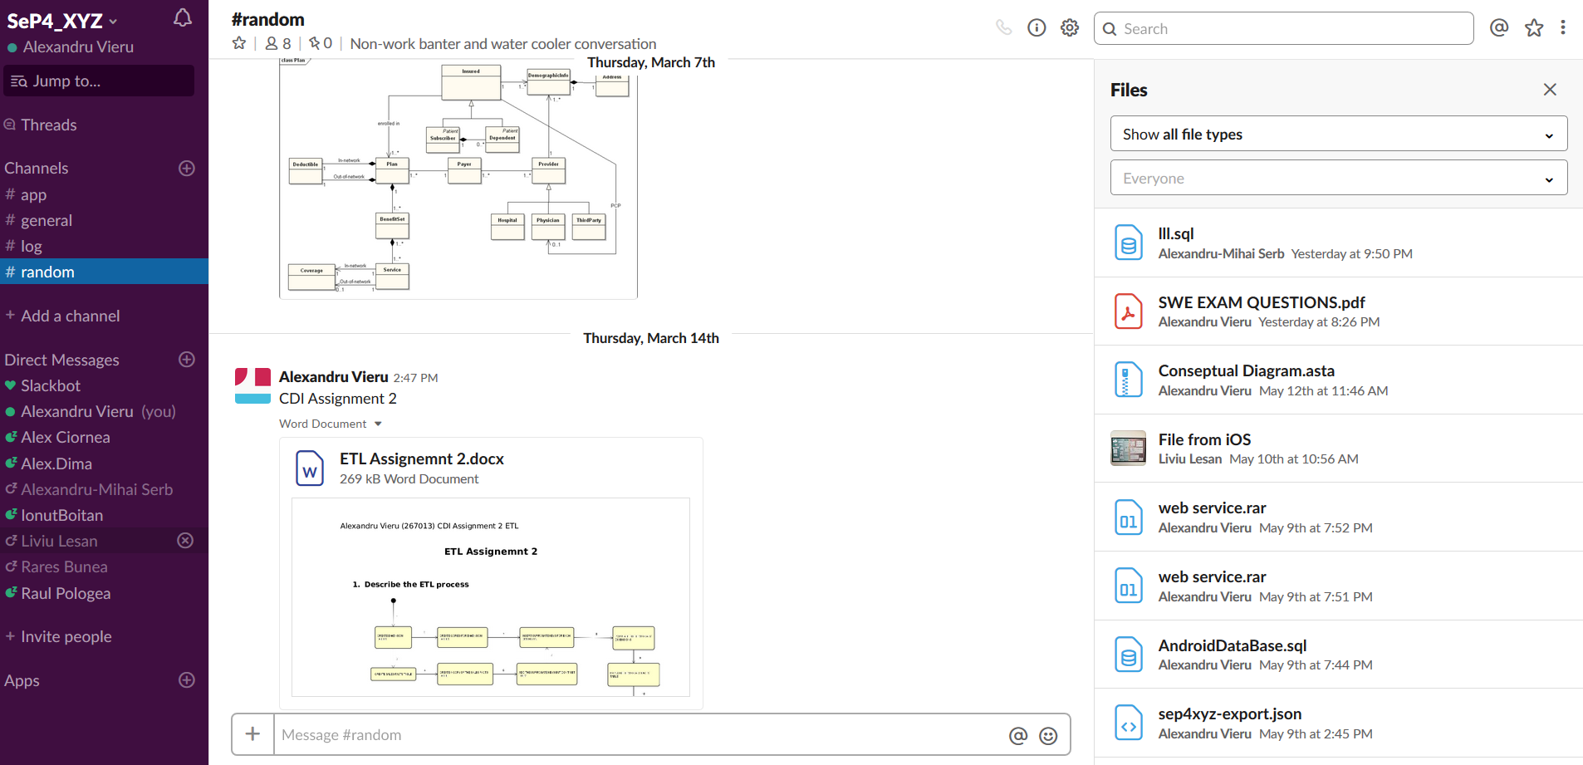

The other tool we used was GitHub since it was decided that it is the perfect tool for sharing code between us and other documents and files such as diagrams.

***Figure 2 GitHub repository history***

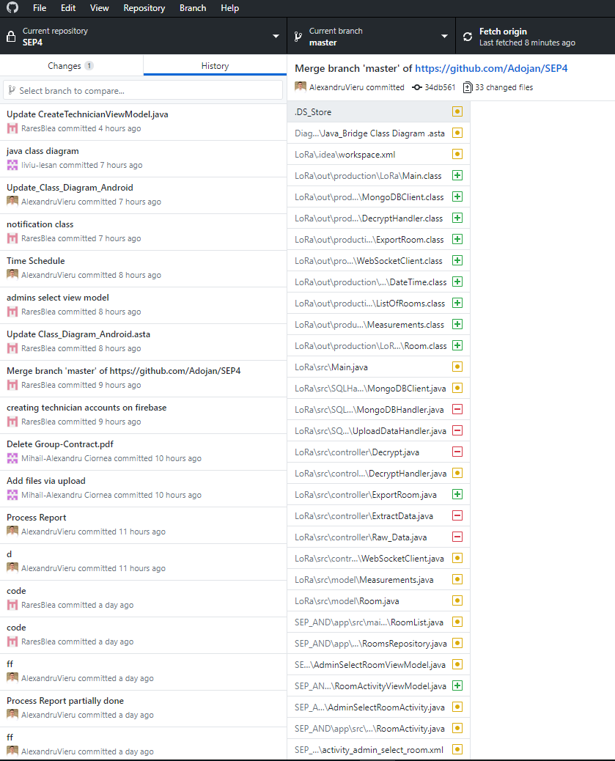

However, communication with the other two groups had to pe kept at all time since the 3 groups had to merge together at the end to produce a working system.

The entire SEP group’s activities were organized into meetings. The meetings where established to take place each week on a Thursday starting from 8:20 AM and were mandatory to attend since they provide crucial information about the stage of the project and how the individual tasks where assigned.

The scheduled meetings where given an estimated time of around 8 hours sometimes lasting less due to group members having to leave early or lasting longer due to falling behind schedule.

Each of the meetings had their own set of requirements and goals which had to be completed before the next one started since not completing them would have consequences on our workflow.

Towards the end of the project, we encountered difficulties regarding the project’s workflow due to some group members not doing their job and sabotaging the rest of the teams. Also, some group members were not showing interest in helping their teammates with problems of common interest.

This occurrence forced us to seek help from the project’s supervisors which was given and after certain changes where made, the project continued onwards.

The scheduled meetings went well in the beginning of the project but started to deteriorate as we advance further on. As some teams took longer and longer breaks, a gap was formed between the members and combined with the lack of interest in other group member’s problems, resulted in a slower workflow and meetings in a more random style.

Workflow was kept at a constant pace in the beginning of the report but started to diminish upon reaching the middle of our project. This happened mainly due to the individuality showed by some groups and members towards others.

# 2 Group Description

Our group was made up initially of 10 members, two of them did not show up for the scheduled meetings, so they have not been mentioned on the cover of this report or in this chapter.

In this chapter the group members will be described based on their subgroup.

## 2.1 Embedded engineering

Alexandru Dima Mircea

Liviu Lesan

Ionut Boitan

## 2.2 Database engineering

Alexandru Ciornea

Alexandru Mihai Serb

Alex is the most database-skilled member of the team. Since he has previously worked in the database field in other school and personal projects, he holds great knowledge on the subject and represented a great asset to our team. He was the main designer of the Database side. When the time was tight, he showed great implication by putting in extra hours of work.

Raul Pologea

Raul is one of the three members of the Database branch of the project. In this project he worked towards achieving the many sub-goals of the team by ensuring that everyone was doing their job and by working himself on the tasks assigned. He believes that no matter how unfavorable the situation may be, a good team coordination will almost always lead to a good result.

## 2.3 Android development

Alexandru Vieru

Alexandru has a previous education in Civil Engineering and has worked in the field of construction for 3 years. During this time, he has gained experience on how to meet deadlines and how to organize a team to reach certain set goals.

After this period, he has moved to Denmark and finished an education in IT Network and Electronics Technology at Business Academy Arhus. During this time, he has gained experience and knowledge on how to write reports in the IT field.

Currently he is enrolled in the ICT education at VIA University to pursue a degree in software development.

He is considered to have high standards when it comes to working for a project and considers himself to be a good team player.

Hard work, determination and never give up once you reach obstacles are his creed.

Rares Dumitru Bunea

# 3 Project Initiation

This chapter will focus on discussing the topic that has been give to this project team from our school. The given assignment focuses on 3 major aspects.

Retrieve sensor data from a room which is in our school.

Send this data to a storage unit using the network provided by our supervisors.

Retrieve the data and make it so that it can be available for a give user that uses an android application.

The group was formed by our supervisors and was not free of choice and the group members where merged from multiple ICT classes.

Our planning for this project went mostly well, for the give assignment. The meetings we had gave us the possibility to communicate with each other about the different stage of the report we were on and asked for help when falling behind.

This gave us a sense of purpose and most where motivated to complete the given tasks to reach the next steps for this project.

Although this sounds perfect in theory most times things do not go as well as the are planned to. Many times, we struggled with completing certain tasks which proved to be more difficult to solve than expected.

Some of these issues where solved at the end while others where not able to complete on time due to a certain team not doing what they promised and signed up to do.

Most of the tasks where accomplished thanks to a strict and well organized regiment which included a risk assessment document which was more to inform the people participating in this project about the given tasks and their set completion time and also about the risks involved if they do not put the required work into them.

A group contract was formed in which we all agreed with the written set of rules and the consequences that will occur if the rules will be broken.

As mentioned before, this works fine in theory but in practice it’s a different story.

While the estimated time had plausible values, the actual time spend on certain tasks took longer than expected thus resulting in the group falling behind schedule.

# 4 Project Description

The problem statement for this project was created based on the case we received from the school. Our costumer required 3 tasks which where critical to accomplish.

First task was to configure a device that would get CO2,humidity and temperature readings from a room inside our school.

The second step was to store these readings into a database which resided on a server on one of the school’s networks.

Lastly, we were asked to create an android application with which users could connect to the database and retrieve the readings which were stored.

Once all the given tasks where clear, we moved forward and created a customer description to better understand what their actual needs and expectations are for this project.

In the delimitation chapter of our problem statement we chose the methodology and the aspects that were most important and relevant for this project and discarded those that were deemed not relevant.

Another key element that was implemented and mentioned before in this document, was our Risk Assessment, where we allocated a grade of importance for the given tasks. This gave us a strong understanding on which of them where considered critical and which were considered less important.

This helped us to better understand the level of involvement for this assignment and practice caution not to break any of the set rules.

# 5 Project Execution

In this part of the report we will discuss how the execution part went and what methods we used to respect the given deadline.

The method used was Unified Process which we considered to be beneficial for our group due to the group not being able to understand and implement SCRUM since the methodology proved to be complex.

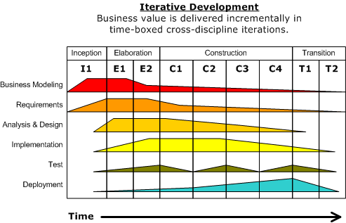

By using Unified Process, we divided our time into 4 stages which are Inception, Elaboration, Construction and Testing.

In the Inception part we formed our group after which we generated the project idea and started with our initial planning.

Once the all the tasks from the Inception where completed we moved on into the Elaboration stage of our report.

We first started to create User Stories which were essential to understand what our customer wanted. Upon completion we created the user requirements which where divided based on their importance faction into functional and non-functional requirements.

Based on the functional requirements, we generated a Use Case diagram, which better illustrated what tasks the system should perform.

Use case descriptions where made for the use cases and their task is to explain in more detail each use case and the precondition and post conditions needed for them to function.

Activity diagrams where also made to show the user interaction with the system and how it would behave if certain tasks where executed differently.

A domain model was created which shows how the different elements in our system are tied up and how they communicate with each other.

And finally, system sequence diagrams where created that show the interactions starting points and end points for the different components for the given system.

During the construction phase for this project, the 3 subgroups started working on their own, each establishing their own pace.

During this phase the groups started working on creating conceptual diagrams which gives a clearer understanding on how the code is structured and how different elements form relations with each other. Upon completion a class diagram was created for each of the subgroups, which contained also the logic behind their stage of the system.

Sequence diagrams where also made since they provided a detailed explanation on how the different components interact and communicate with each other.

The final stage of our project is the Testing stage. In this part each team where assigned the actual implementation for the given system.

Some of the teams started on implementing parts of their code and testing it after. If the tested part of the code was successful, then they would move on to the next part of the implementation followed up by other tests.

# 6 Personal Reflections

## 6.1 Android Team

Alexandru Vieru:

As a member I was disappointed on how the whole team collaboration worked. People where not showing up for meetings or showing up one or two hours late .

This project was given a strict time schedule to complete and would have succeeded to a higher extent if people would have not neglected their responsibilities.

A plan has been made in the beginning which split the work across multiple sprints and was structured so that all the tasks would be completed before the deadline.

In the beginning of the project everything seemed to work well, people where showing up for the scheduled meetings , but further down into the project when the actual design began, some groups where starting to neglect their responsibilities which drastically decreased our productivity and put us behind schedule.

We had to remove one of our members from the group, since this person has been given many opportunities to work with us, but unfortunately, he decided to ignore the plan completely and not care about if this project would succeed or not.

By dismissing him we lost a group member, and as such certain delimitations had to be made in the project. Certain functionalities for the app had to be removed.

We hope that in the future that these events will not happen anymore and if they do actions will be taken sooner than before.

Rares Bunea:

## 6.2 IOT Team

Alexandru Mircea Dima:

Ionut Boitan:

Liviu Lesan:

## 6.3 Database Team

Alexandru Ciornea:

Alexandru Mihai Serb:

Raul Pologea:

The project had a good and promising start. After creating and meeting all the new teammates we set up a set of rules and decided what was our next step. However, as the project carried on, we encountered various difficulties with the other sub-teams and teammates. From people showing up extremely late to the meetings to other teams not showing up at all, resulting in various setbacks and delays.

One other problem we had to deal with was the pauses and breaks during the project and the fact that some teams such as the Database team took fewer, medium-length breaks and other teams took many long breaks such as coffee or cigarette breaks. However, after splitting into branches that problem was eliminated, and our team could work at full efficiency.

The overall project carried our fine, taking into consideration the difficulties caused by the other teammates, and I hope that in the future the process will be more fluid.

# 7 Supervision

Our supervisors were helpful. We went to them for advice on how to design our project and help us better understand the connections between classes and how the code should be implemented. However, we wished that at certain points we could have gotten more help since many times we struggled with our coding and could not get any support.

# 8 Conclusions

Throughout the project period, we encountered many challenges. Some tasks were easy to complete while others proved to be more difficult, however with the help of each other and our supervisors, we were able to overcome most of.

Many hours have been spent for this report and at times this became exhausting but at the same time, this improved our skills in our line of work.

Tension arose between us at certain moments, but where stopped in time since they proved prove to be toxic for the continuation of the project.

Unified process proved to be useful for our planning and made our lives much easier by implementing this as a work method.

Database design and implementation was not finished, and this set us back a long ways and caused stress and frustration due to some group members not wanting to collaborate with the rest of the team, deciding to segregate themselves for not good reason.

Overall all these factors contributed in producing an outcome and made the rest of us improve in certain aspects of our education.